Module | WSQ- Business Analytics (SF)
Name | Koh Chun Yao
Date | 20 Feb 2026

Assignment-4b Submission

Task 1 – CONFIGURE A DRILL THROUGH PAGE

Provide screenshot of drill through page

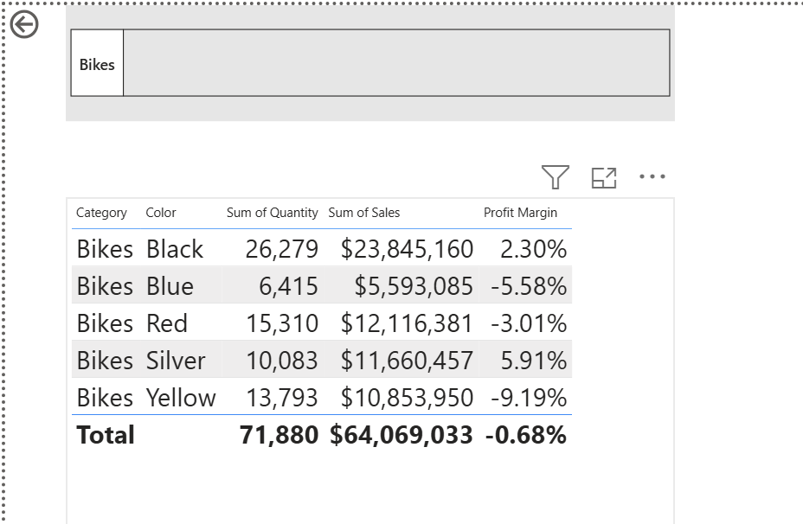

Task 2 – ADD CONDITIONAL FORMATTING

Provide screenshot of configured Conditional formatting

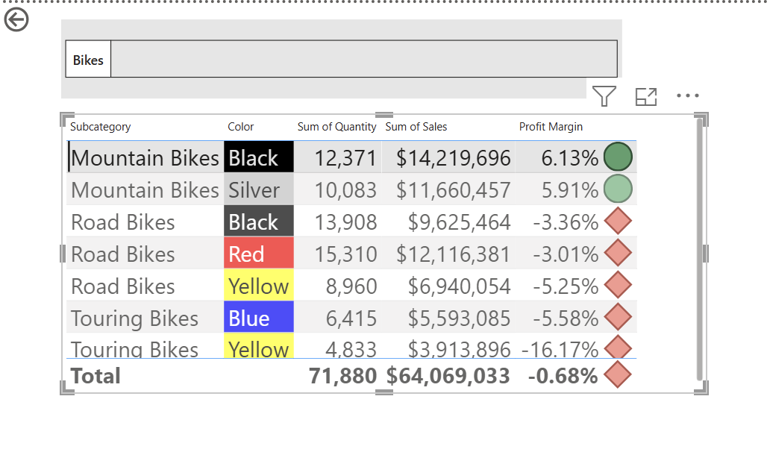

Task 3 – ADD BOOKMARKS AND BUTTONS

Provide screenshot of configured Bookmarks and Buttons

